**Homework: Implementation and Performance Comparison of Optimization Algorithms**

**Homework Objective**

Through the implementation and comparison of various optimization algorithms (Gradient Descent, Conjugate Gradient, Line Search, Modified Gradient Descent, Newton's Method, Quasi-Newton Method, and Direct Methods), students will gain a deeper understanding of the principles, applicable scenarios, and performance of these algorithms in solving optimization problems. Students are required to design experiments, analyze the convergence speed, computational efficiency, and accuracy of the algorithms, and attempt to improve one of the algorithms to enhance its performance.

**Project Requirements**

1. **Implementation Requirements**:
   * Independently implement the following optimization algorithms:
     + Gradient Descent (GD)
     + Conjugate Gradient (CG)
     + Line Search
     + Modified Gradient Descent (MGD)
     + Newton's Method
     + Quasi-Newton Method (e.g., BFGS algorithm)
     + Direct Methods (e.g., Nelder-Mead or Powell's Method)
   * Each algorithm should support the following functionalities:
     + Customizable initial points
     + Customizable learning rate or step size (if applicable)
     + Record the objective function value and gradient norm at each iteration
2. **Test Functions**:
   * Use the following test functions for experiments:

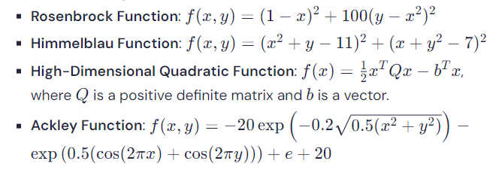

* + Students may choose additional test functions (e.g., Beale Function, Sphere Function) to extend their experiments

1. **Experiment Design**:
   * Compare the performance of different algorithms in the following aspects:
     + **Convergence Speed**: Number of iterations vs. function value
     + **Computational Efficiency**: Execution time
     + **Accuracy**: The difference between the final solution and the true optimal value
   * Analyze the impact of different initial points on the performance of the algorithms.
   * Explore the effect of different learning rates, step sizes, or parameter choices on the algorithms.
2. **Improvement and Innovation**:
   * Students are required to attempt to improve one of the algorithms (e.g., dynamic learning rate adjustment, combining line search strategies, hybrid algorithms) and compare the improved algorithm with the original one to analyze the effectiveness of the improvement.
3. **Report Requirements**:
   * Submit a detailed experimental report, including:
     + Implementation details of the algorithms
     + Experiment design and selection of test functions
     + Visualization of experimental results (e.g., convergence curves, runtime comparison charts)
     + Analysis and discussion of experimental results
     + Design ideas and performance analysis of the improved algorithm
   * The report should be at least 2000 words and include the code and instructions for running it.

**Evaluation Criteria**

1. **Algorithm Implementation (30%)**:
   * Whether all required algorithms are correctly implemented.
   * Whether the code is clear and well-structured.
2. **Experiment Design and Results (30%)**:
   * Whether the selection of test functions is reasonable.
   * Whether the experimental results are comprehensive and accurate.
3. **Improvement and Innovation (20%)**:
   * Whether the improved algorithm design is reasonable.
   * Whether the improvement is significant.
4. **Report Quality (20%)**:
   * Whether the report content is complete and logically clear.
   * Whether the charts are clear and the analysis is in-depth.

**Final Deliverables**

1. **Code**: Include the implementation of all algorithms and experimental code, along with instructions for running it.
2. **Experimental Report**: Provide a detailed description of the experimental process and result analysis.
3. **Visualized Results**: Convergence curves, runtime comparison charts, etc.